# Five Colleges MARC Record Loading

# Documents Without Shelves

## Collection Code: FCDWS

## Files

Notification when files are ready come via email. It is important to grab the file as some archives are removed from the site. The files are prepared by Marcive and have already been configured. Files are delivered monthly.

## Preprep Files

The sets can include a mix of formats such as ebooks, streaming audio, etc. Some records will also have multiple 856s or none at all. For the time being, no modifications will be done to the file.

## Outline

1. Convert the file (step 1 and 2)
2. Run a fix on the converted file
3. Check the file against the database to determine what records are new, updates or multimatches
4. Troubleshoot any multimatches
5. Load new and then update records
6. Delete url from bibliographic record.

## Process

### Retrieve MARC file(s)

1. Once an email notification has been received, download file(s) from site. File name will be in all CAPS.
2. Change the file name to lowercase.

### Load Records into Aleph

1. FTP the file to the /exlibris/aleph/u21_1/fc101/scratch directory on the Aleph server. The Aleph Cataloging Client can also be used to upload the file in the fc101/scratch director. (Note: To do this use Import Records, select input file and convert procedure.)
2. (**Step 1)** In the Cataloging Client, under “Aleph”, click on Services/Load Catalog Records and Convert step 1 (file-01)
   * 1. Input file: name of the marc file all lower case
     2. Output file: this can be any name
     3. Select “Marc records delimited by 1D separator”
     4. FCL01

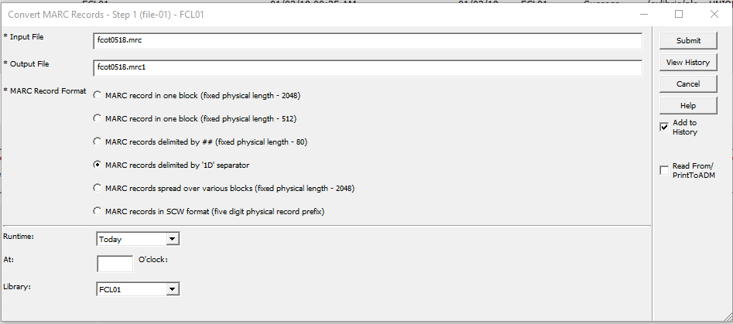

1. **(STEP 2)** Click on Services/Load Catalog Records and select Convert step 2 (file-02)
   * 1. Input File: The name of the file from output in step 1
     2. Output file: A new file name
     3. Marc Record format: Marc Record
     4. Library: FCL01
     5. Click Submit

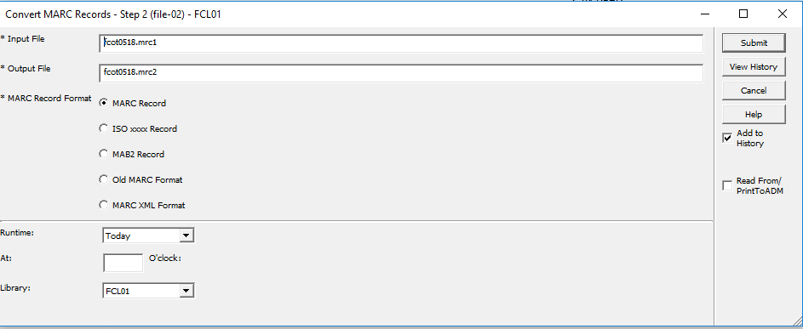

1. **(FIX)** Click on Services/Load Catalog Records and select Fix Catalog Records (manage-37)
   * 1. Input File: Name of output file from step 2
     2. Output File: New name
     3. Input File Type: ALEPH Sequential
     4. Fix Routine: DPFIX
     5. Update Database: No

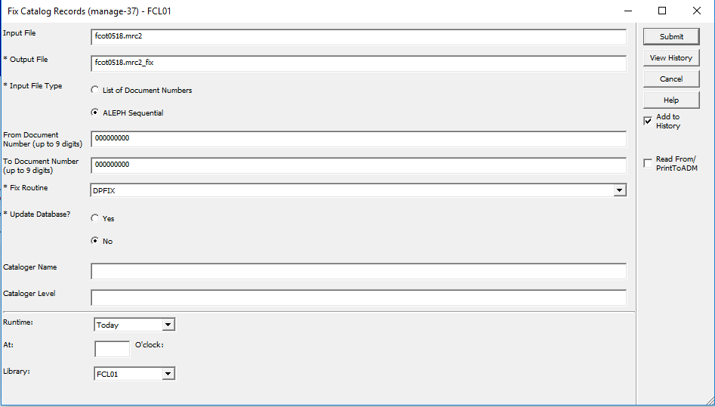

1. **(CHECK Database)** Click on Services/Load Catalog Records and select Check Input File Against Database (manage-36)
   * 1. Input File: Name of output file from manage-37
     2. Output File 1, 2, & 3: give number 0,1, and 2 to 3 output file names. These map to: 0->new, 1->updates, 2->multimatch
     3. Match Selection: OCLC (you might have to select DP35 to avoid false multimatches)
     4. Tag for multiple Match Record Numbers: 989 (or some other field never used such as 902)
     5. Library: “FCL01”
     6. Click Submit

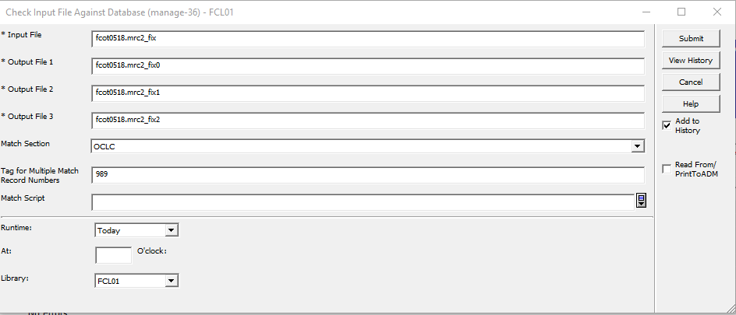

1. (**NEW RECORDS LOAD**): There is data in the file with the 0 at the end. Load that file under Services/Load Catalog Records and select Load Catalog Records (manage-18)
   * 1. Input file: File name with 0 at the end from manage-36
     2. Output file for Rejected Records: Add new file name
     3. Output file for Logging System Numbers: Add new file name
     4. Procedure to Rune: Add new records to the database
     5. If Updating Current Records: Replace fields within a record
     6. Indexing: Full
     7. Fix Routine: None
     8. Merge/Preferred Routine: None
     9. Character Conversion: OCLC_UTF_TO_UTF
     10. No. of Catalogers Currently Working: Multi-users
     11. Library: FCL01

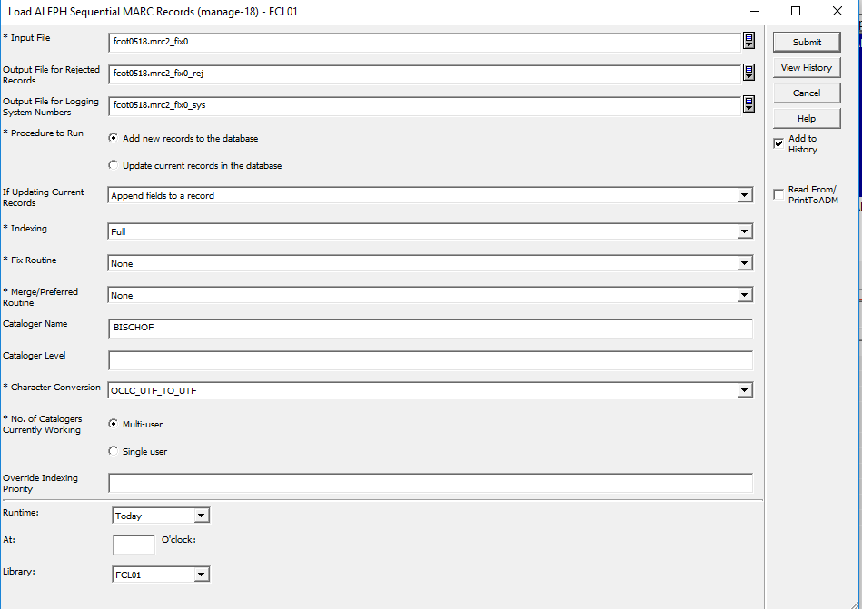

1. **(Add Inventory for New Records)** Add Items/Holdings for New Records Loaded. Go to Serves/Load Catalog Records and select Create Holdings and Item records based on Bibliographic Data (manage-50)
   * 1. Input file: File name for the list of bib sys numbers created in last step manage-18
     2. ADM Library: DEP50
     3. HOL Library: FCL60
     4. Expand Procedure: None
     5. Main Field: 949#1
     6. Item/Holdings Creation Table: tab_hol_item_create_ummarcit
     7. Holdings Record Creation Mode: Replace existing holdings records
     8. Item Record Creation Mode: Replace existing item records
     9. Holdings/Item Creation Interaction: Create holdings records based only on new items
     10. ADM Cataloger: Your login username to Aleph
     11. ADM Cataloging Level: 20
     12. HOL Cataloger: Your login username to Aleph
     13. HOL Cataloging Level: 20
     14. Update Database: Yes
     15. Check Item records: Yes
     16. Library: FCL01

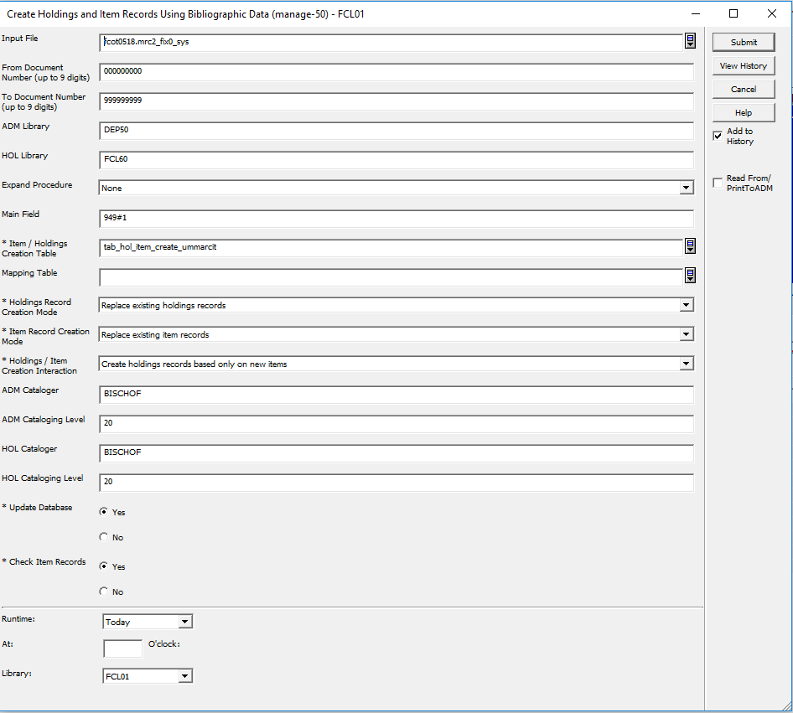

1. **(Remove URLs from New Record Bibs)** Remove URLs from Bib records: Go to Services/Catalog Maintenance Procedures and select Global Changes (manage-21)
   * 1. Input File: File name with the Bib sys numbers from manage-18
     2. Output file: File name for log
     3. Update database: Yes
     4. Line in Record
        + 1. Tag: 856
          2. First Indicator: #
          3. Second Indicator: #
     5. Delete Field: Yes

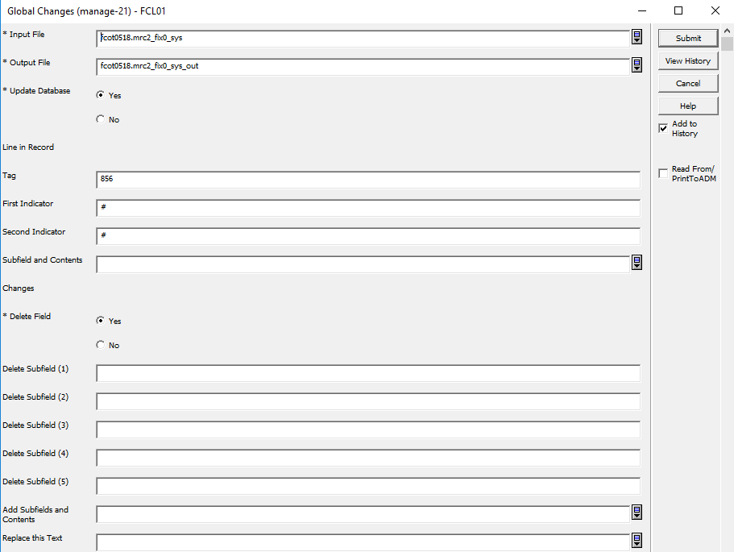

1. Verify: You can always verify this by checking a sample of the sys numbers. The sys number file created in manage_18 is saved in alephe/scratch. You can open that file and check the Sys numbers. Item records are in DEP50.
2. (**UPDATES TO RECORDS LOAD**) There is data in the file with the 1 at the end. Load that file under Services/Load Catalog Records and select Load Catalog Records (manage-18)
   * 1. Input file: File name with 1 at the end from manage-36
     2. Output file for Rejected Records: Add new file name
     3. Output file for Logging System Numbers: Add new file name
     4. Procedure to Rune: Update current records in the database
     5. If Updating Current Records: Replace entire record
     6. Indexing: Full
     7. Fix Routine: None
     8. Merge/Preferred Routine: None
     9. Character Conversion: OCLC_UTF_TO_UTF
     10. No. of Catalogers Currently Working: Multi-users
     11. Library: FCL01

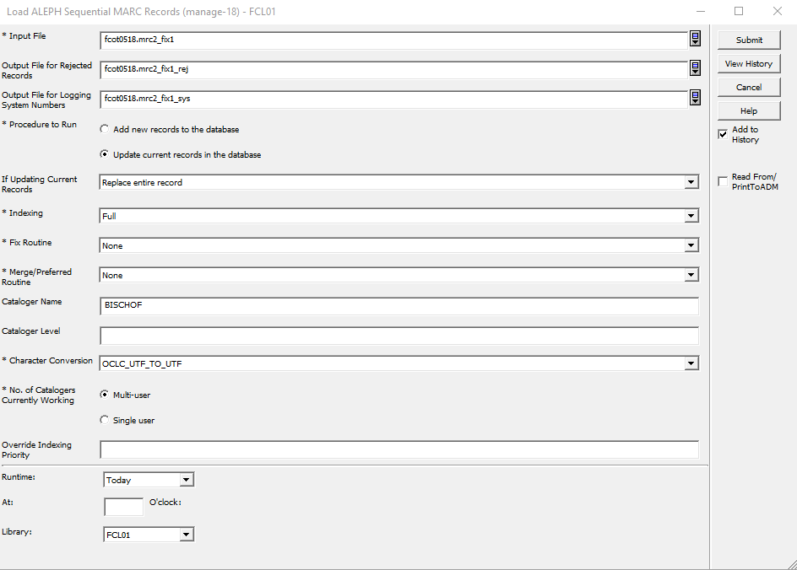

1. **(Add Inventory for Updates)** Add Items/Holdings for New Records Loaded. Go to Serves/Load Catalog Records and select Create Holdings and Item records based on Bibliographic Data (manage-50)
   * 1. Input file: File name for the list of bib sys numbers created in last step manage-18 (this is the file with 1 in it)
     2. ADM Library: DEP50
     3. HOL Library: FCL60
     4. Expand Procedure: None
     5. Main Field: 949#1
     6. Item/Holdings Creation Table: tab_hol_item_create_ummarcit
     7. Holdings Record Creation Mode: Replace existing holdings records
     8. Item Record Creation Mode: Replace existing item records
     9. Holdings/Item Creation Interaction: Create holdings records based only on new items
     10. ADM Cataloger: Your login username to Aleph
     11. ADM Cataloging Level: 20
     12. HOL Cataloger: Your login username to Aleph
     13. HOL Cataloging Level: 20
     14. Update Database: Yes
     15. Check Item records: Yes
     16. Library: FCL01

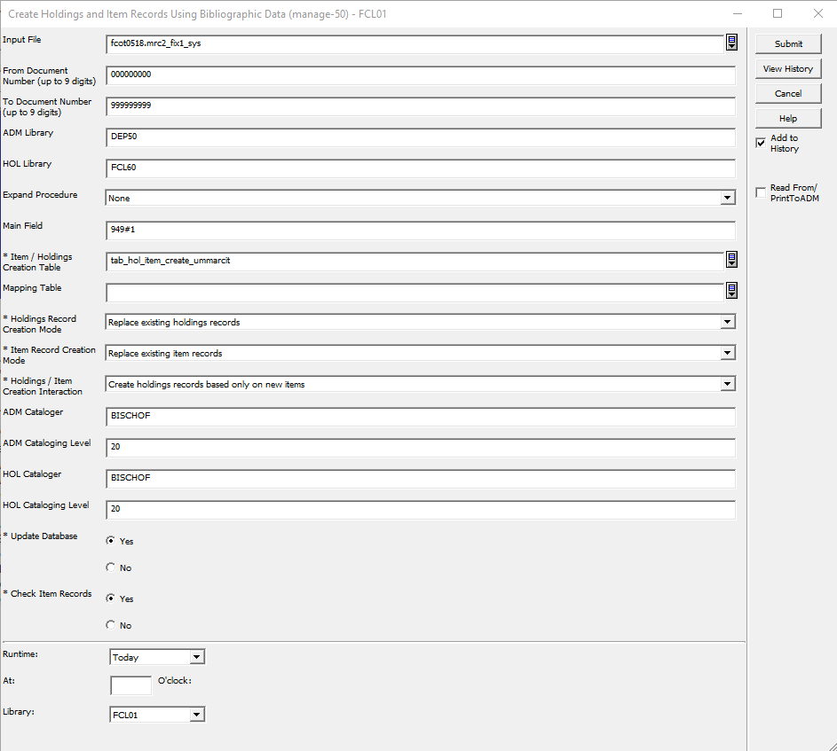

1. **(Remove URLs from Updates)** Remove URLs from Bib records: Go to Services/Catalog Maintenance Procedures and select Global Changes (manage-21)
   * 1. Input File: File name with the Bib sys numbers from manage-18. The one with 1 in it.
     2. Output file: File name for log
     3. Update database: Yes
     4. Line in Record
        + 1. Tag: 856
          2. First Indicator: #
          3. Second Indicator: #
     5. Delete Field: Yes

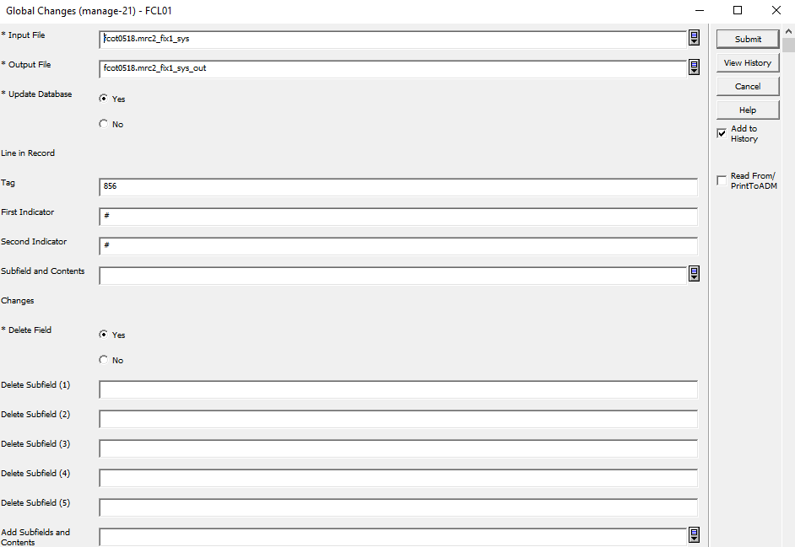

## Management & Tracking

* + - 1. Update the FC In Common Electronic Resources Sheet: <https://docs.google.com/spreadsheets/d/1TAIR-RHSVAHsWnD8spaq7e4USxxRNL1f7Gk8MRxNjJE/edit#gid=0>
      2. Update Coral